Software Engineering lab-CMPS310-B52
Milestone1-PearlMart Inventory Management System-Group5
Theory section L51, L52
Submission Date: Sunday 18th of October 2206
Name: Latifa AlNaemi-202405639-33.3%
Name: Salwa AlFarzan-202405400-33.3%
Name: Aisha Alkaabi-202304167-33.3%

DECLARATION: We hereby certify that no part of this project or product has been copied from any other student’s work or from any other sources except where due acknowledgment is made in the project. No part of this project/product has been written/produced for us by any other persons.
Start of Milestone1:
First to ensure that we had the right understanding of what is Agile and scrum we revisited lecture 1 slides to ensure we had a full understanding of the process. Also, we had visited the lab02 which we were working on GitHub and learning how to create a repository and to Manage it. Before working on the GitHub, we first got our self-familiar with the requirement of the system understanding how the system works who are the external entities(actors) what do they do. The data that need to be saved and functions the at need to be done within a system and business rules that need to be followed.
After making sure we know how the system works we then checked what the milestone needs from us. Milestone 1 required creating 3 important software engineering tables DFD in 3 levels (0,1and 2), a use case diagram and a class diagram. Also, the projected needed 4 use case specifications and finally a traceability and an assumptions table.
A Major concept of a scrum process sprints therefore we organized our project into 2 sprints according to the information given in provided project file.
Sprit 1 | Sprint 2
- Implementing the Agile/scrum in GitHub and understanding scrum concepts.  - Creating level 0, 1 and 2 DFD diagrams.  - Building a Use Case diagram.  - Comparing and Analysis. | - Use Case Specifications  - Building a Class Diagram  - Important Tables:  - Traceability Table  - Assumption Table
We made sure that we understand important concepts that help us start this project.
Sprint 1:
Components of Sprint 1:
1-Implemeting the Agile/scrum in GitHub and understanding scrum concepts.
2-Creating level 0, 1 and 2 DFD diagrams.
3-Building a Use Case diagram.
4-Comparing and Analysis.
Our Sprint 1 Work:
1-Implemeting the Agile/scrum process in GitHub and understanding scrum concepts:
We started by organizing our GitHub repository before starting the diagrams, so we have a place to document and organize our diagrams. Also to ensure that every group member has the access to the diagrams and documents being able to work simultaneously.
- Our Project board GitHub Project https://github.com/users/latifa-alnaemi/projects/2/views/1
- Main Group Repository: https://github.com/latifa-alnaemi/Team-B52-GU5.git
First thing after creating the repository I invited my team members to it using their GitHub accounts. We created a simple readme and a .gitignore for the visual paradigm and the word files as they are major concepts of GitHub.
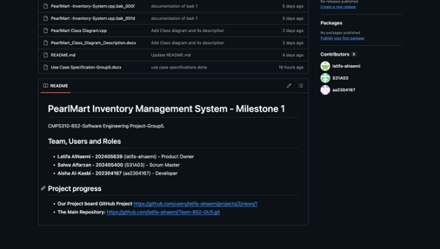 | 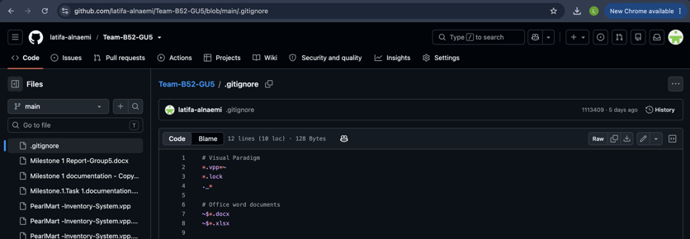

Then after that we created a milestone 1 that ends on the 18th of October, inside a project their 3 iterations for our issues (To do, in process and lastly Done). you can see down that we have used this iteration in all our tasks with evidence.
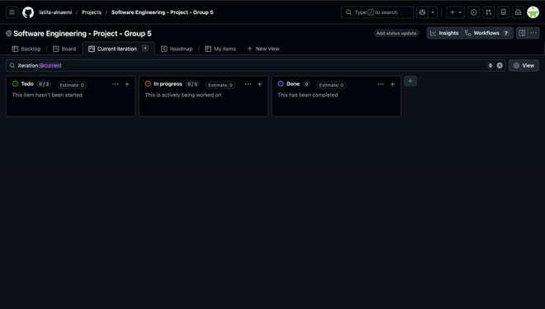
Lastly after making sure that our GitHub repository is ready, we started our project
.
2-Our level 0, 1 and 2 DFD diagrams:
Level 0 DFD Diagram:
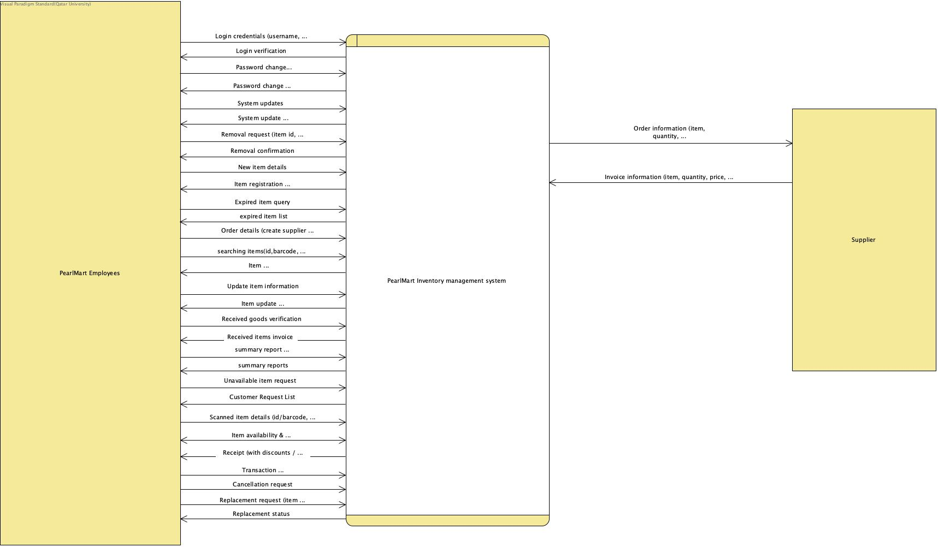
Level 1DFD Diagram:
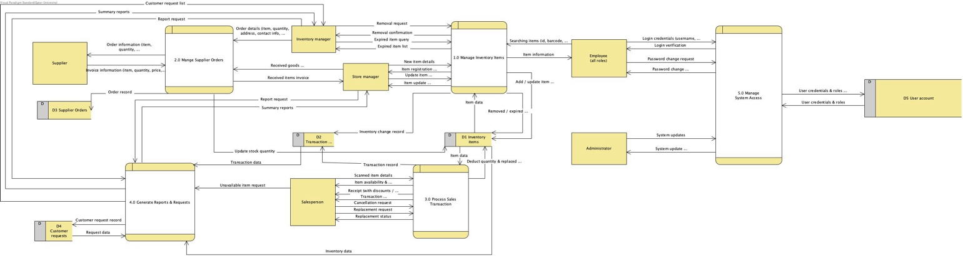

Level 2 DFD Diagram:
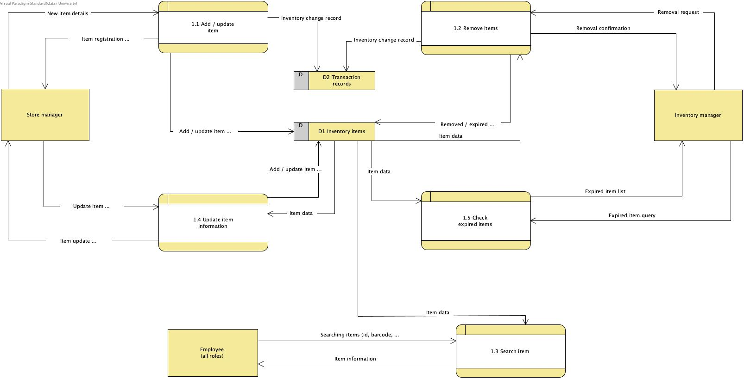
What the DFD shows:
how the data (information) moves through the PearlMart inventory system. The data flow is shown through the five processes, (1.0 Manage Inventory Items, 2.0 Manage Supplier Orders, 3.0 Process Sales Transactions, 4.0 Generate Reports & Requests, 5.0 Manage System Access) and how they exchange with the five data stores (D1 Inventory System, D2 Transaction Records, D3 Supplier Orders, D4 Customer Requests, D5 User Accounts). It shows how D1 receives goods by (2.0), and addition and removal of goods with (1.0). And it also reveals how D2 provides reports. As well as, showing how no data enters and leaves without being accounted for in the DFD diagram.

3-Building a Use Case diagram:
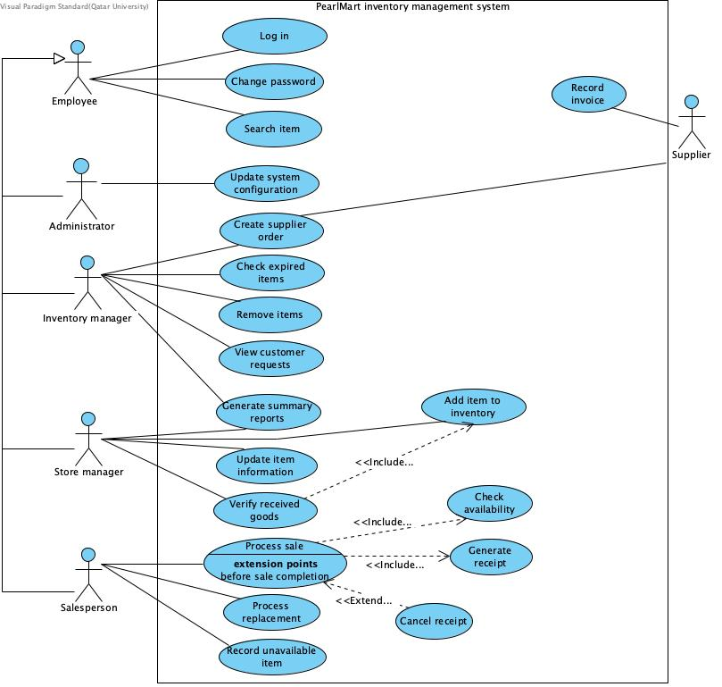
What the use case diagram shows:
is who interacting with the system and why. All employees (Administrator, Inventory manager, Store manager, Salesperson) inherit the login and password change ability from Employee, and how each has their own responsibilities that were assigned to them. For example, the administrator updates the system, the Inventory manager checks all expired items and creates supplier’s orders, the Store manager adds items and verifies received goods, the Salesperson processes the sales and any requirements. In addition, it reveals the included use cases (Checking availability, generating receipts), as well as the extended use case (Cancel receipt) that works in optionally. The supplier that is on the other end is only involved in ordering and invoicing.
4-Comparing and Analysis:
 | DFD | Use case diagram
Strengths | Shows data flow, the shared data stores, the ability to trace actions throughout the levels. | Shows all roles, responsibilities, scope, as well highlighting the mandatory activities.
Limitations | Does not show who is authorized to which responsibilities, and no clear order of steps | Does not show where that data is saved after processes, no flow of information
Best suited for | Designers and analysts | Clients and end users (e.g. Ms. Sara)

Complementary use:
Each diagram exposes the limitations of the other. The DFD reveals the missing data flow that the use case fails to show, e.g. the removed items not being updated to D2, and how customer requests are never written into D4. The combination of all employees in (Level 0) blurs each type of employee’s responsibilities and authorized access. The DFD diagram never reveals the process of validations that are required in the system, and the use cases specifications are the ones that reveal them, as well as showing who is responsible and authorized to do such actions.
Which is better suited to a specific question:
if the question is “where is the inventory quantities are updated? “The DFD diagram is more suited Since each data flow is clearly visible like the flow that comes to and from a process/data store, this satisfies the requirements of this scenario which are the consistent data flow from / to either location. The use case diagram lists actions, such as Remove items, verify received goods and process sale, so if the question is “which role is authorized to remove expired goods?” this question is best answered by the use case diagram, which as mentioned before shows which role is related / responsible to each action.
Challenges of Sprint 1:
- Use of GitHub as a main tool to track progress was unfamiliar to students, therefore some time was needed for them to get better at using it.
For example, setting up branches, linking issues to pull requests.
- Getting familiar with visual paradigm took some time to master, as well as only one person being able to edit on the project at a time.
- Transforming the background story into different types of diagrams.
Improvements to be applied to Sprint 2:
- Daily updates of the board rather than every couple of days.
- Reviewing the background story again before starting sprint 2.
- Updating the report of sprint 2 regularly rather than creating it at the end of the sprint.
Evidence of using scrum process in Sprint1:
Board:
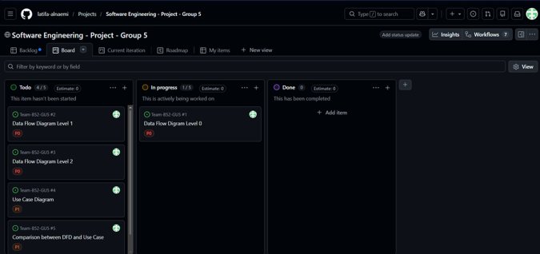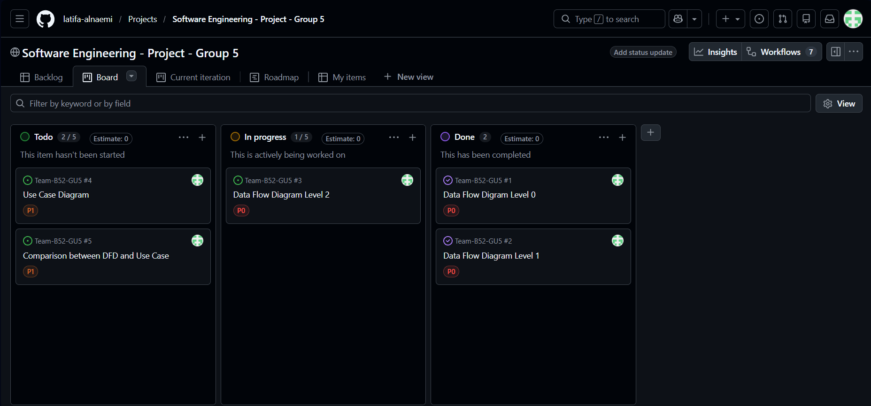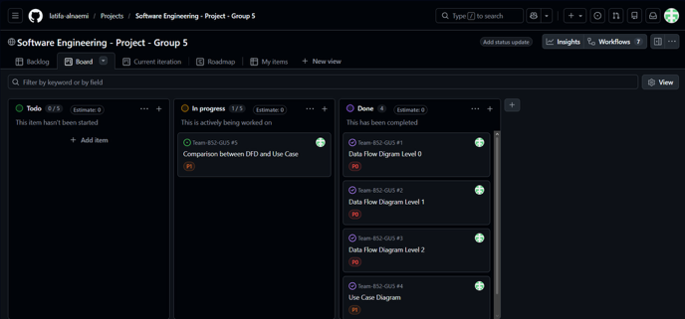
Road Map:
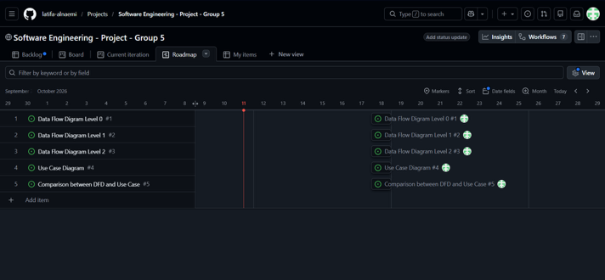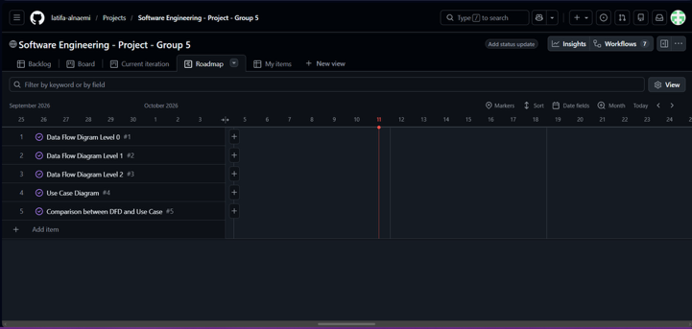

Sprint 2:
Components of Sprint 2:
1-Use Case Specifications
2-Building a Class Diagram
3-Important Tables:
- Traceability Table
- Assumption Table
Our Sprint 2 work:
1-Use Case Specifications:
First Use Case: Create Supplier Order (UC001)
Use Case ID | UC001 Create Supplier Order
Brief Description | When the Manager prepares an order for the supplier with items needed, the delivery location, the contacts and any other system check and saves the order and send it to the supplier.
Primary Actors | Inventory Manager
Trigger | The Inventory Manager checks the if additional stock is needed or customer request. Then he selects the option to create supplier order
Preconditions | The Inventory manager should be authorized and is logged in the system.
Postconditions | The order is recorded and labeled with a distinctive Order ID, then the order status, items and details are also recorded and sent to the supplier.in addition the system notes important inventory activity
Main Success Scenario
Actor Action | System Response
1.Inventory Manager selects the option of Create supplier Order | 2. Then the system asks the manager to enter the needed information of items such as location quantity and contacts. Or choose the supplier.
3. the Manager enters the needed information to the system. Also, the manger can enter comments | 4.The system checks whether the manger have entered all the needed and correct information.
5. The Manager confirms the order. | 6. the system records the order information and assign a unique ID to the order also notes activity.
 | 7.System sends the order request to the supplier.
 | 8.The system confirms order and inform the inventory manger

Alternative flows
4.a- The information entered is invalid or missing, the system will ask the manager to enter the correct information.
5.a- the manager can cancel the request before the final confirmation.
7.a- Sending issue is found the system will send a message to the manager with failure of sending the request.

Second Use Case: Verify Received Goods (UC002)
Use Case ID | UC002 Verify Received Goods
Brief Description | When the orders arrive from the supplier the store manager checks the order and verifies it, the order id accepted the inventory updates to the new stock.
Primary Actors | Store Manager
Trigger | Order arrives at the store and the manger opens the verify received goods in the system.
Preconditions | The store manager is authorized and logged in. The supplier is registered within. A system
Postconditions | The order items are recorded into the inventory therefore the quantities of the order should increase and if it is a new item added to the inventory.
Main Success Scenario
Actor Action | System Response
1. The order arrives to the store, and the manager inspects it thoroughly. He selects the verify order option. | 2. The system display the verify goods page, showing the invoice, ordered item and the quantity.
3.Store manager enters the item ID or barcode and the quantity and other information of the received items. | 4. The system checks wither the received items matches the requested the ordered items.
5.Manager approves the system verification. | 6. after the verification the system will update the inventory stock with the new quantities. Using the trigger (include) add item to inventory.
 | 7. The System display a confirmation message to adding to the inventory.

Alternative flows
2.a- invoice or order not found, the system can’t find the invoice of the order.
3.a No entered data or missing information, the system will ask the manager to enter data into missed tabs.
4.a- the ordered item is missing or wrong items. The system will stop the process and display missing or incorrect order message to the store manager. And change the order status to missing order
5.a- the Manager cancels the verification the system will stop the process and mark the status of the order as unconfirmed.

Third Use Case: Process Sale (UC003)
Use Case ID | UC003 Process Sale
Brief Description | After the customers finishes shopping they head to the billing counter where the salesperson enters the customer items in the system. Then the system checks the availability of each item, get the total price and after purchase a receipt is created the inventory is updated.
Primary Actors | Salesperson
Trigger | The salesperson starts a new sale in system and starts to scan items barcode at the billing counter.
Preconditions | The items exist in the inventory the salesperson is logged in and authorized.
Postconditions | A receipt is created, the items are deducted from the inventory after purchase.
Main Success Scenario
Actor Action | System Response
1.A new sale is started by the salesperson. | 2.The system will start an empty page of sale to start entering items.
3.The salesperson will scan items barcode or item ID, and quantities. | 4.The system checks the availability of items and quantity by triggering the check availability (include)
 | 5.after checking availability the item is added to the receipt and the price is added to the total price.
6.The salesperson and the system will repeat the 3,4 and 5th step for each item. | 7.After having added all the items the system gets the total and prepare pre-payment receipt.
8.Salesperson get the payment from the customer and also the cancelation of receipt can be done in this step by the extension of cancel receipt. | 9.After the payment the system will generate the final confirmed receipt (include) which contains prices, discounts or any other payment information.
 | 10.The system deducts the purchased items from the inventory.

Alternative flows
4.a- Item not found. After the system triggers the check availability the item cannot be listed in the inventory therefor the system will show an error message that the item not found.
4.b- The requested item quantity is unavailable or invalid. The requested quantity of an item can exceed the valid stock, or it can also be out of stock. The system will display a message of invalid quantity.
7.a- The final receipt is empty. The system will stop and show an error message of “empty receipt”
10.a- Item is out of stock in inventory. After deduction of items some stocks can be unavailable therefore the system should mark those as out of stock.

Fourth Use Case: Remove Items (UC004)
Use Case ID | UC004 Remove Items
Brief Description | The inventory manager has the choice to remove items from the inventory due to reasons such as expiration. The manger should identify the item to be removed and the quantity to be removed then the system removes it from inventory if possible.
Primary Actors | Inventory Manager
Trigger | An authorized employee such as the inventory manager decides to remove an item from inventory and choose the remove items choice in the system.
Preconditions | The inventory manger authorized and logged in the system. Items exist in the inventory
Postconditions | The item or quantity is successfully removed from inventory, and the removal is recorded
Main Success Scenario
Actor Action | System Response
1.the inventory manager selects the remove items option in the system. | 2.the system opens the remove item page and asks the user to enter the item information.
3. the user manager scan the barcode or enters the item ID and the quantity that need to be deducted also the reason of removal | 4.The system the checks wither the item exists is the inventory and also checks the quantity requested to be removed.
5.the user confirms the removal of item. | 6.the system removes the item or the specified quantity from the inventory, shows a massage of removal and records the removal into removal history.

Alternative flows
4.a- the item not found. The barcode or the item ID doesn’t exist in the inventory the system will display an error message item not found ang goes back to step 3.
4.b- the quantity not eligible, the number entered may exceed the stock of item or the number entered is wrong (negative or zero). The system will display an error message that the number entered is wrong and goes back to step 3 and asks the user to enter a valid number.
5.a-removal cancelation. The manager can cancel the removal of an item. The system stops the removal and exists the remove item page.

2-Building a Class Diagram:

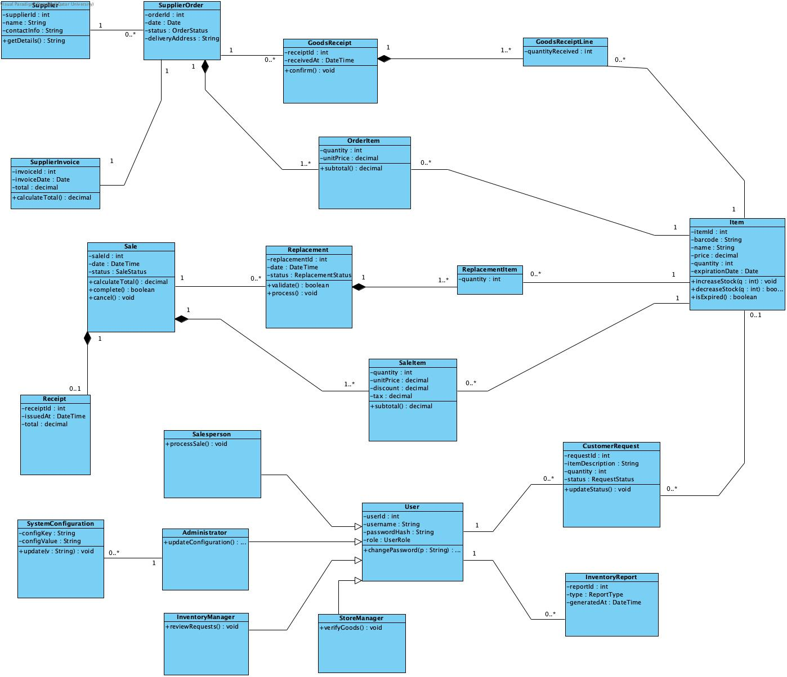
1. System Overview & Scope:
This document provides a comprehensive structural description of the Inventory and Point of Sale (POS) Management System class diagram. The architecture integrates supplier procurement, order fulfilment, retail sales operations, customer requests, and role-based user management.
Architecture Note: InventoryTransaction Exclusion
In this revised design, the InventoryTransaction class has been omitted. Stock counts are maintained directly within the Item entity utilizing internal methods (increaseStock and decreaseStock), while historical movements and auditing are derived directly through primary business documents such as GoodsReceipt and Sale.
2. Key System Components:
2.1 User Management & Security:
User (Base Class): Acts as the base entity for system accounts containing credentials (-userId, -username, -passwordHash, -role) and security operations like +changePassword().
Salesperson: Specializes User to handle customer checkouts via +processSale().
StoreManager: Specializes User to verify inbound shipments using +verifyGoods().
InventoryManager: Specializes User to review inventory requests and backorders via +reviewRequests().
Administrator: Specializes User to manage global system configurations via +updateConfiguration().
SystemConfiguration: Stores key-value system settings (-configKey, -configValue) updated by Administrators .
2.2 Procurement & Supplier Operations:
Supplier: Represents vendor information (-supplierId, -name, -contactInfo). A supplier handles zero or more purchase orders (1 to 0..*).
SupplierOrder: Represents purchase orders (-orderId, -date, -status, -deliveryAddress) containing one or more OrderItem line items (1 to 1..*).
SupplierInvoice: Tracks vendor billing invoices issued against purchase orders (-invoiceId, -invoiceDate, -total).
GoodsReceipt & GoodsReceiptLine: Manages inbound warehouse receipts. A GoodsReceipt contains one or more GoodsReceiptLine items (1 to 1..*), specifying quantities received for specific catalog items.
2.3 Sales, Billing & Returns:
Sale & SaleItem: Initiated by a Salesperson. A Sale tracks order totals and fulfillment status, containing one or more SaleItem line items recording quantities, unit prices, discounts, and taxes.
Receipt: Represents proof of payment issued for a completed sale (1 to 0..1).
Replacement & ReplacementItem: Manages customer returns or product exchanges linked to a Sale, specifying ReplacementItem quantities.
2.4 Inventory Core & Demand:
Item (Central Entity): Stores product catalog details (-itemId, -barcode, -name, -price, -quantity, -expirationDate). Stock modifications are managed directly through +increaseStock(q) and +decreaseStock(q).
CustomerRequest: Logs user requests or backorders (-requestId, -itemDescription, -quantity, -status), optionally linking to an Item (0..1).
InventoryReport: Represents stock summary reports generated by users (-reportId, -type, -generatedAt).
3. Relationship & Multiplicity Summary
Source Class | Target Class | Multiplicity | Relationship Description
Supplier | SupplierOrder | 1 : 0..* | A supplier receives zero or more orders.
SupplierOrder | SupplierInvoice | 1: 1 | An order is invoiced by one supplier invoice.
SupplierOrder | GoodsReceipt | 1 : 0..* | An order is fulfilled through goods receipts.
SupplierOrder | OrderItem | 1 : 1..* | An order contains one or more order line items.
GoodsReceipt | GoodsReceiptLine | 1 : 1..* | A receipt contains one or more receipt line items.
GoodsReceiptLine | Item | 0..* : 1 | Each receipt line item references a catalog item.
OrderItem | Item | 0..* : 1 | Each order item references a catalog item.
Salesperson | Sale | 1 : 0..* | A salesperson processes zero or more sales.
Sale | Receipt | 1 : 0..1 | A sale generates at most one receipt.
Sale | Replacement | 1 : 0..* | A sale is associated with zero or more replacements.
Sale | SaleItem | 1 : 1..* | A sale contains one or more sale line items.
SaleItem | Item | 0..* : 1 | Each sale item references a catalog item.
ReplacementItem | Item | 0..* : 1 | Replacement line items reference catalog items.
CustomerRequest | Item | 0..* : 0..1 | Customer requests optionally link to a catalog item.
Administrator | SystemConfiguration | 1 : 0..* | An administrator updates system configurations.
User | CustomerRequest | 1 : 0..* | A user records customer requests.
User | InventoryReport | 1 : 0..* | A user requests inventory summary reports.

Evidence of using scrum process in Sprint 2:
Board:
 | To Do | In Process | Done
Class Diagram | 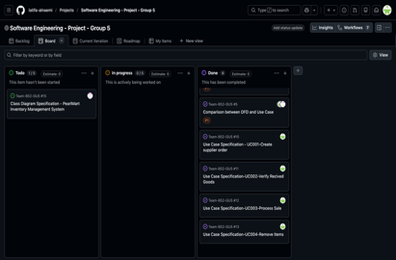 | 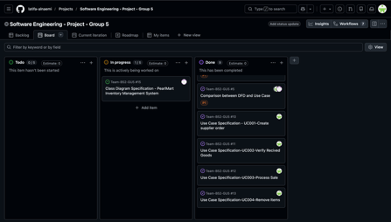 | 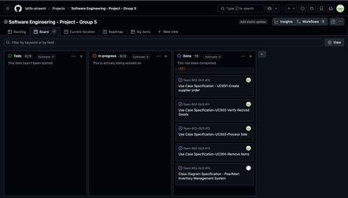
UC001 | 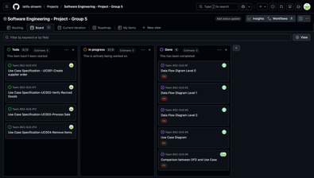 | 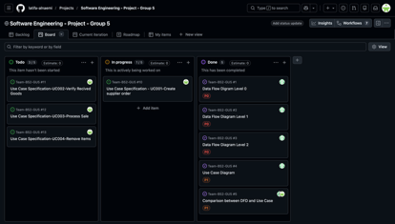 | 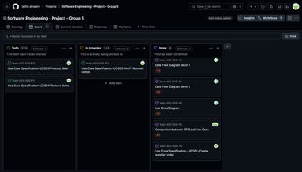
UC002 | 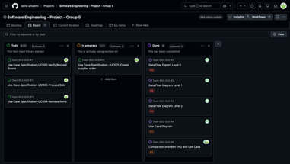 | 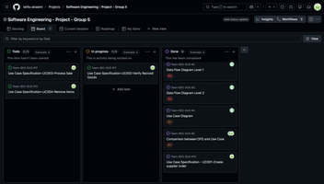 | 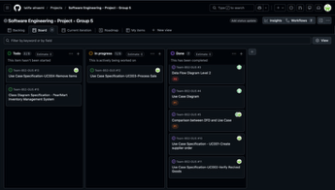
UC003 | 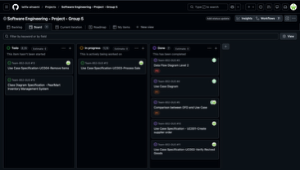 |  | 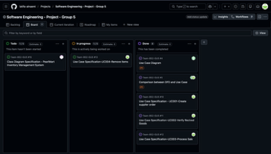
UC004 | 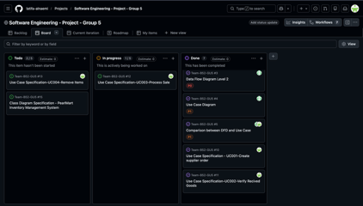 |  | 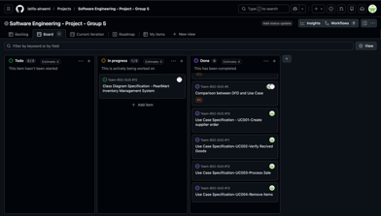
Roadmap:
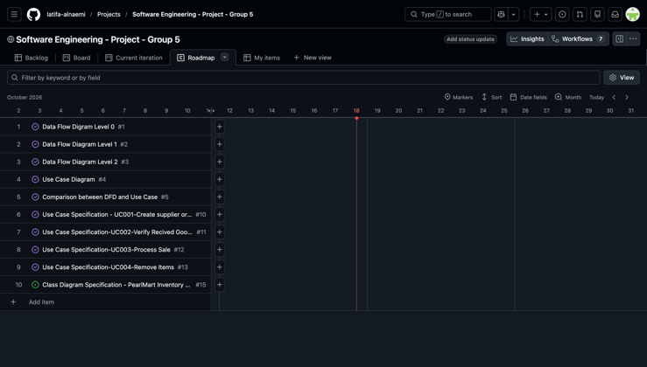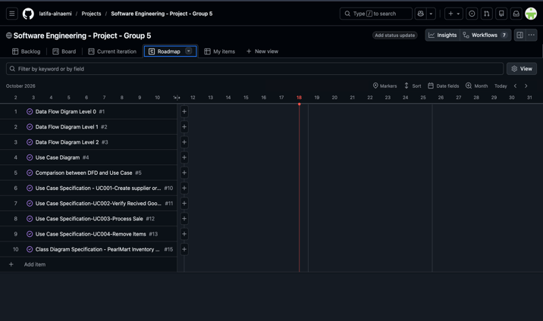

3-Important Tables:
Traceability Table:
Requirement | DFD Processes | Use Case Diagram | Class Diagram
User Authentication and Access
Management of Inventory
Orders from Supplier
Reports and Customer requests

Assumption Table:
Assumption | Justification

